厦门迪太进出口有限公司
XIAMEN DITAI IMP.& EXP. CO.,LTD
地址：中国厦门禾祥西路鸿升大厦8A
8FL, Hongsheng Building, West Hexiang Road, Xiamen, Fujian, China
TEL:0592-26808108 FAX:0592-2680880 E-mail: irene.zhang@xmditai.com

Sodium Nitrite Food Grade CAS 7632-00-0

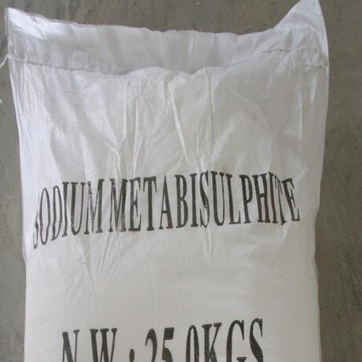​

USES

It is mainly used for producing nitrogenous base chemical compound; it is the raw materials of azo dyes,etc.; Used as the mordant and bleaching agent of fabric dyeing; used as the metal heat treatment agent, the cement early strength agent, the antifreeze,etc. It is also used in pharmacy and chemical trade.

Storage:
Store it in the shady, cool and dry storehouse. Keep away from kindling material and heat source, the packaging should be sealed, can't keep in touch with the air, should preserve with flammable, combustible substance and reducing agent ,etc. , prohibit to store and transport together with other things; carefully load and unload in order to prevent damaging the container and package.

Application of sodium nitrite
1. sodium nitrite is mainly used to know nitro compounds, azo dyes and other raw materials,
2. sodium nitrite as the mordant for dyeing, bleaching agents
3.sodium nitrite also used as a metal heat treatment, plating corrosion inhibitors,
4.sodium nitrite used for instrument disinfection medicine, preservatives.
5.sodium nitrite as cement early strength agent, antifreeze, etc.
6.sodium nitrite in meat products used in the color development processing agent, anti-microbial agents, preservatives.
specification of sodium nitrite
Specifications | Ist grade
Some items are superior to the National Standard
NaNO2(as bry basis)% | 99.0min
NaNO3(as bry basis)% | 0.80max
Insoluble matters in water,% | 0.05max
Moisture,% | 1.8max
Chlorides(as CL, on bry base),% | 0.10max

